**My Learning:**

1. Objective and function of the introduction

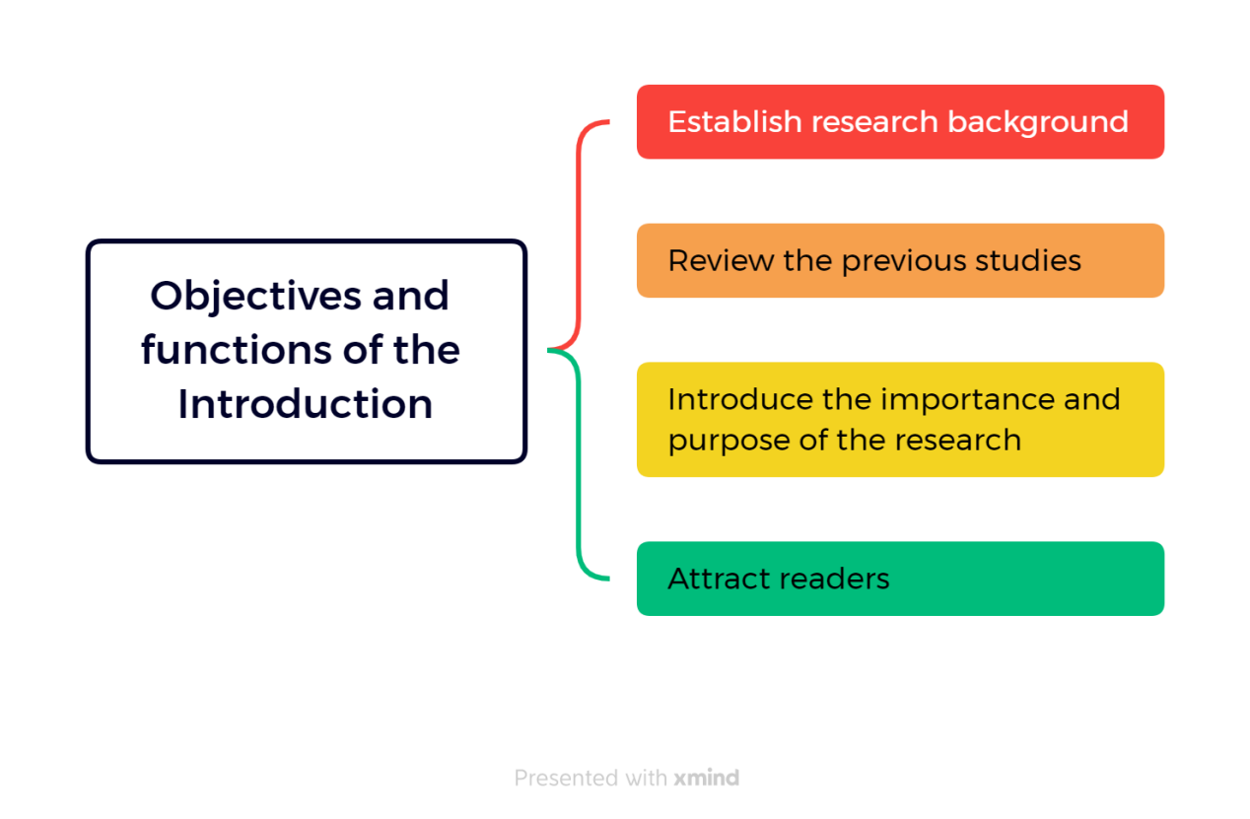

1. How to write a introduction

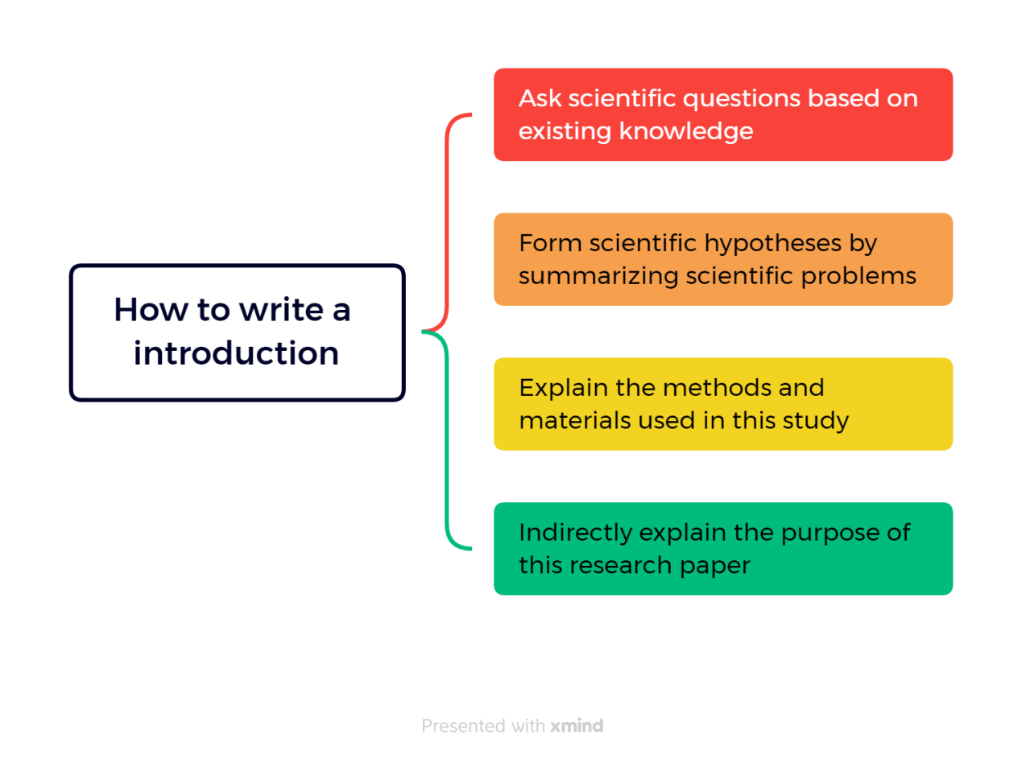

1. Write the introduction in five steps

* General statements about a field of a research to privide the readers with a setting for problems.
* More specific statement about the aspects of the problems already studied by other researchers.
* Statements that indicate the need for more investigation.
* Very specific statement giving the purpose of the writer's study.
* Optional statement that give a value or justification for carrying out the study.

1. Introduction and write a roadmap



1. English thesis tense

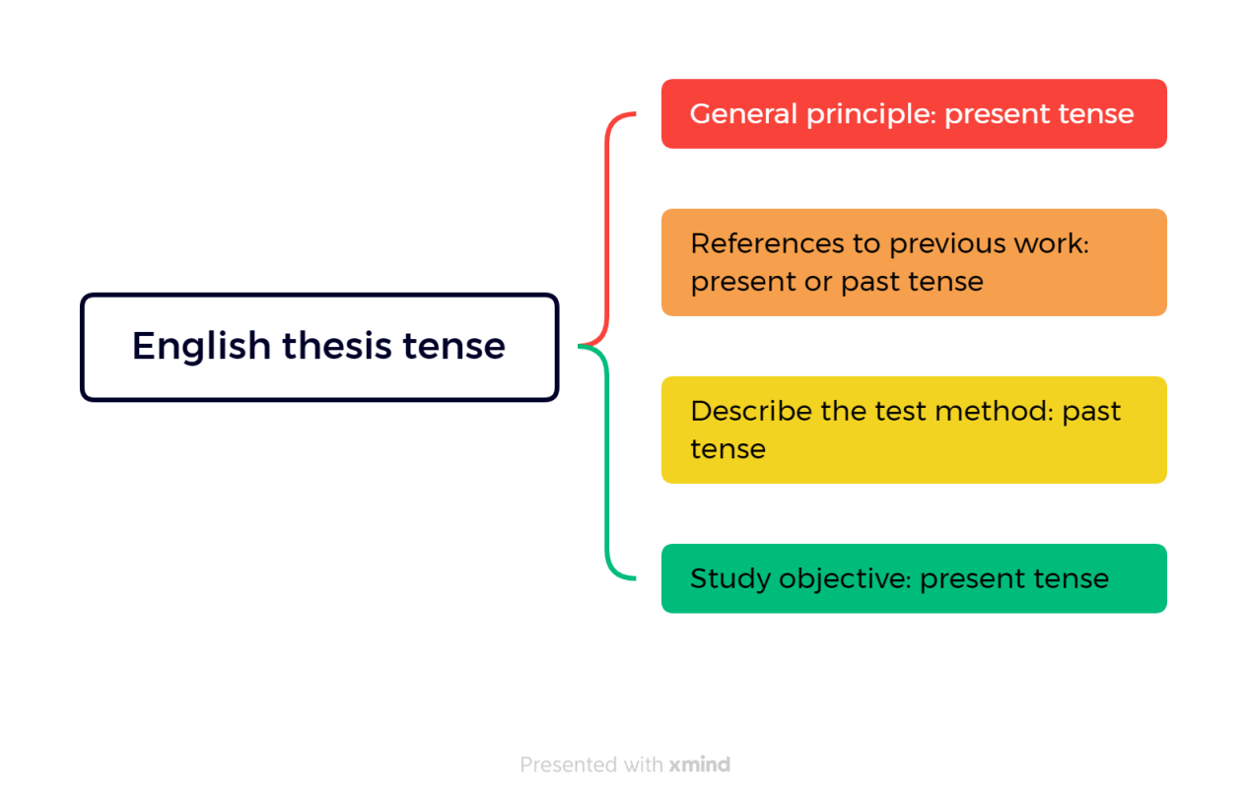

1. Precautions for introduction writing

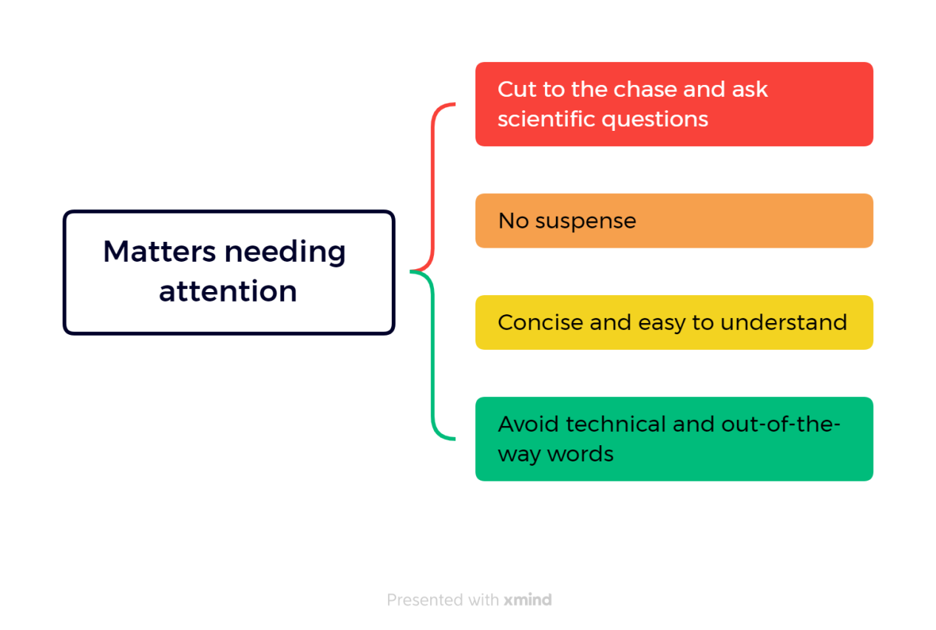

**Outcomes:**

* The purpose of the introduction is to provide research background, introduce scientific problems, and enable readers to understand and evaluate the significance of research results.
* Writing the introduction requires moving from general to specific, using the five-step method that includes presenting the problem, reviewing previous research, stating the hypothesis, explaining the methods, and stating the purpose.
* When writing the introduction, it is important to use appropriate tenses, such as the present tense for general principles, the present or past tense for citing previous work, the past tense for describing experimental methods, and the present tense for stating the research purpose.
* The introduction should clearly and concisely present the scientific problem, avoiding leaving readers confused or uncertain.
* Common issues to avoid when writing the introduction include missing important elements, vague descriptions, being overly long and losing focus, having a narrow background, and using overly general statements.
* When writing the introduction, it is important to avoid overly technical or esoteric vocabulary to ensure readers can understand the content.